Notes: Mixtures and Solutions

Define Mixture

Define Heterogeneous
Example: ___cereal, salad____________

Define Homogeneous
Example: __milk, honey, metal____
3 types of Mixtures
True solution ex. Ex. Lemonade, sugar water
Colloid ex. . Ex. Smoke, jelly, milk, mayo
Suspension ex. . Ex. Muddy water, Jello.

Define Solution
Determined by: particle size of dissolved substance

Define Solute:
Example: ____sugar_________________
Define Solvent
Example: _____water_______________
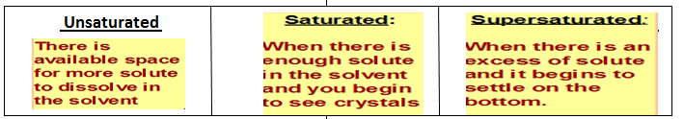

Define Solubility

What does a Solubility Graph tell us?

Define Compound

Define Element

2 or more substance put together but still remains separate

Not mixed well. Can see separate particles

Mixed well. Cannot see individual particles

Description: Mixture of 2 or more substances w/dissolving.
Light passes through
Description: A solution that contains particles that do not settle ever. Light does not pass through
Description: heterogeneous mixture with a fluid and particles. The particles will settle out.

Homogeneous mixture. One substance dissolves in another

In a solution, the substance that is dissolved

In a solution, the substance that does the dissolving

The amount of solute a solvent can dissolve at a particular temperature

It explains & compares the amount of different solutes dissolved at a particular temperature.

Not a Mixture. It’s a combination of 2 or more elements chemically combined making a new substance entirely.

A substance that cannot be broken down. Defined by the number of protons it has.

