Changes in Phases of Matter of Water Diagram

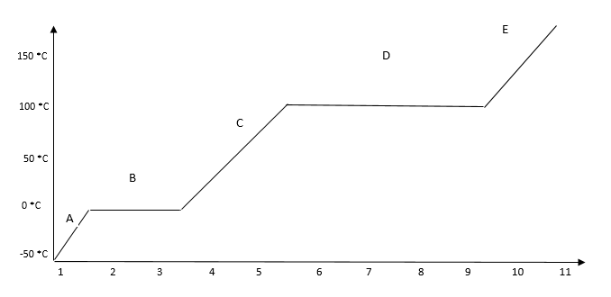
Directions: While using the video in Schoology, complete the diagram below. Be sure to label the axes, each phase and phase change on the line, and draw a simple diagram. Your diagram should be similar to the videos.

1 a. In the diagram, what are the 2 possible phase changes occurring during “B”?
_________________________ _____________________________
b. What are the 2 possible phase changes occurring during “D”?
__________________________ _____________________________
2. Now, knowing where the phase changes are from questions #1

a. T or F- During a phase change, the temperature will not change.
b. T or F- During a phase change, the heat energy will not change.
c. T or F- While in a phase (solid, liquid or gas), the temperature will remain constant.
d. T or F- While in a phase (solid, liquid or gas), the heat energy will remain constant.

3. Knowing that at the very end of Area C it is liquid water and at the very beginning of area E it is gas vapor
a. Do both liquid water and gas vapor exist at the same temperature? ______
b. At what temp does both freezing and melting occur? ______
4. If the temperature changes, can a solid still remain solid for a short time? ________

5. Is energy released (give off) or absorbed (taken in) when a substance changes from a liquid to a gas?
(circle the answer)
6. Is energy released or absorbed during freezing?
(circle the answer)
7. What phase change did we observe when we used the dry ice? _________________________

